**Lab Report No : 02**

**Lab Report Name : Basic Command of Linux Operating System**

**Name:BINODON**

**ID:IT-17046**

**Objectives:Virtual machine,linux operating system.**

**Question :What is Linux command?**

**Answer :**Linux is a operating system. There are two types unix and Linux.All the Linux/Unix commands are run in the ubuntu terminal provided by the Linux system. This terminal is a command prompt of Windows OS. Linux/Unix commands are case sensitive. This includes package installation, file manipulation, and user management. Linux terminal is user-interactive. When user specified then The terminal outputs the results of commands .

**Linux operating system 15 basic and useful commands.**

**Answer :**There are a lot of Linux commands, 15 of them are given below,

1. w
2. sudo
3. ping
4. echo
5. mkdir
6. free
7. rm
8. hostname
9. echo

10.cd

11.bzip2

12.clr

13.groups

14.ls

15.exit

**Command and explanation:**

**Answer :**The operation of basic Linux commands are given below :

1. w: The w command lists the currently logged in users.

Example : 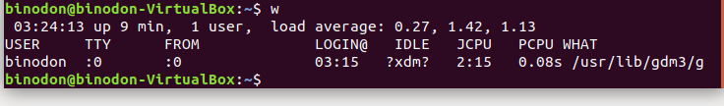

1. sudo : The sudo command is when performing actions that require root or superuser permissions, such as changing the password for another user.

Example:

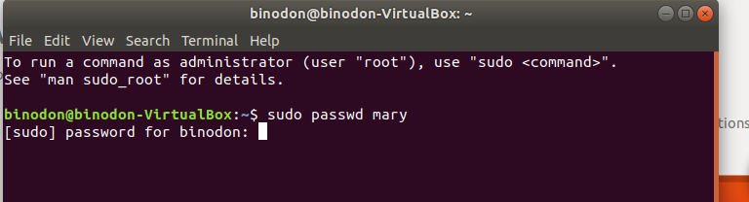

1. ping: The ping command lets you verify that you have network connectivity with another network device..

Example :



1. echo : The echo command prints (echoes) a string of text to the terminal window..

Example :

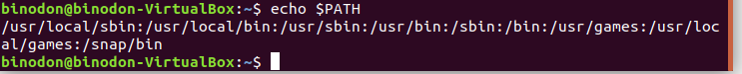

1. mkdir :mkdir command is used to create single or more directories, if they do not already exist (this can be overridden with the –p option).

Example :

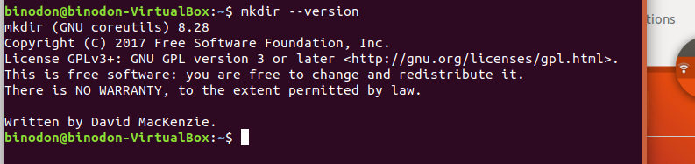

1. free : The free command gives you a summary of the memory usage with your computer..

Example :

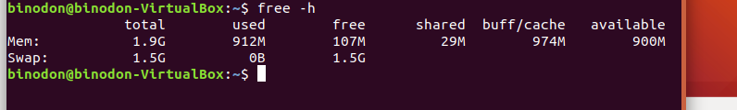

1. rm :rm command is used to remove files or directories .

Example :

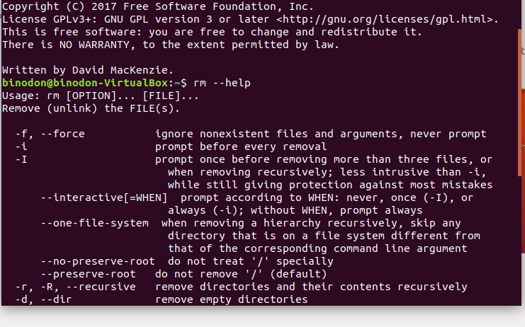

1. hostname–The hostname command is used for show the username .

Example :



1. echo : The echo command can show the value of environment variables.

Example :



1. cd : cd stands for change directory and it does the same as it name stands for.

Example :

C:\Users\ICT\Pictures\cd.PNG

1. bzip2 : bzip2 command is used to compress or decompress files.

Example :

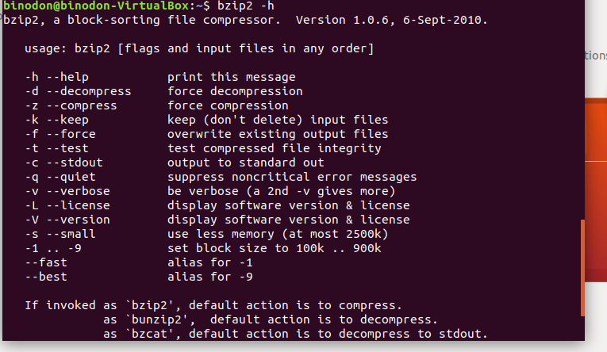

12. clr : clr command is used to clear the whole window.

Example :

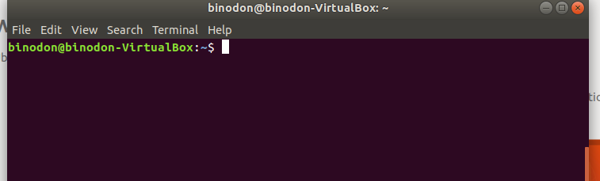

13. groups: The groups command tells you which groups a user is a member of..

Example :

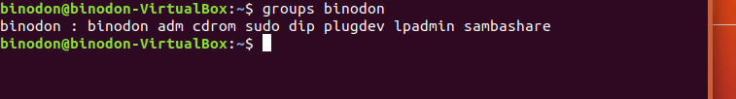

14.ls: It lists the files and folders in the directory you specify. By default, ls looks in the current directory

Example:

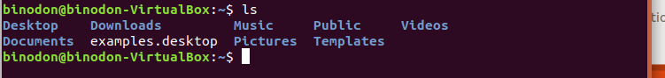

15.exit: The exit command will close a terminal window

Example:

C:\Users\ICT\Pictures\exit.PNG

Conclusion:We are successfully do the lab,And come to know about basic commands of linux.To do this lab we did not face any problem.